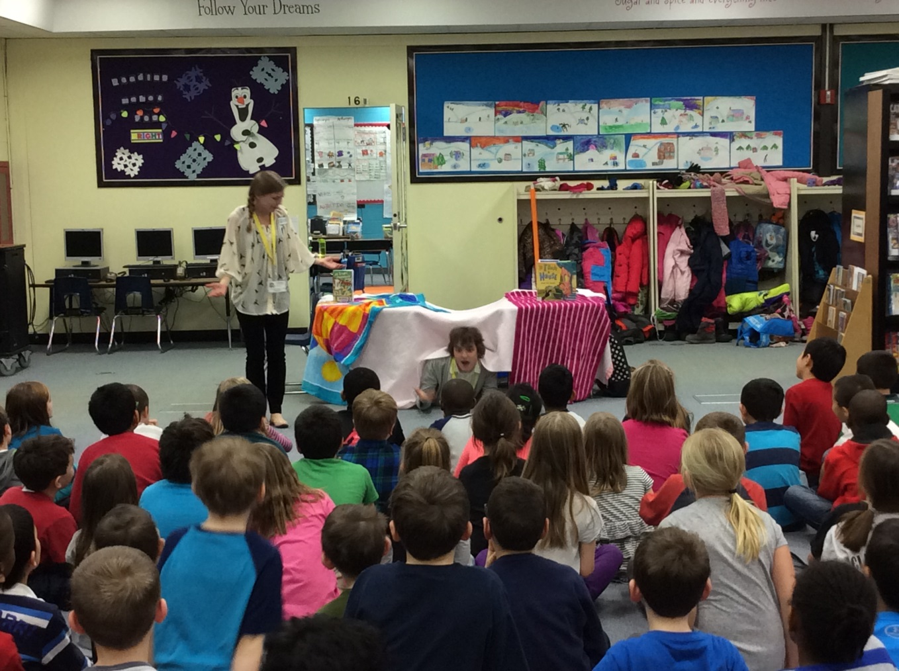

The students of Tate Woods welcomed Miss Kerry and Mr. Josh from the Lisle Public Library on March 10th. Our students were invited to participate in the ReDiscover program. The books: If I Built a House! and The 13 Story Treehouse are featured. Registration for the Family Forts Celebration opens on March 16th.
Check out the Lisle Public Library website lislelibrary.org for more information and registration opportunities.
Celebrating Home with Rachel Rivera Weaver Monday March 16th 4:00
Lego Houses Monday March 23rd and Tuesday March 24th 4:00
Treehouse Treats Monday April 6th and Tuesday April 7th 4:00
D.I.Y. Home Projects Monday April 13th and Tuesday April 14th 4:00
Family Forts ReDiscover Celebration Saturday April 25th 4:30-6:00

